Forestry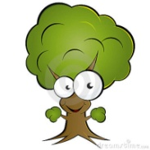

2)
Economic | Social | Environmental

- Where does forestry occur in Canada?
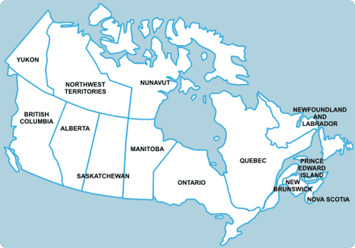
4) 3 methods of harvesting forests:
1)

2)

3)

5)
Disadvantage (-)
Advantage (+)

