Time Zones Quiz

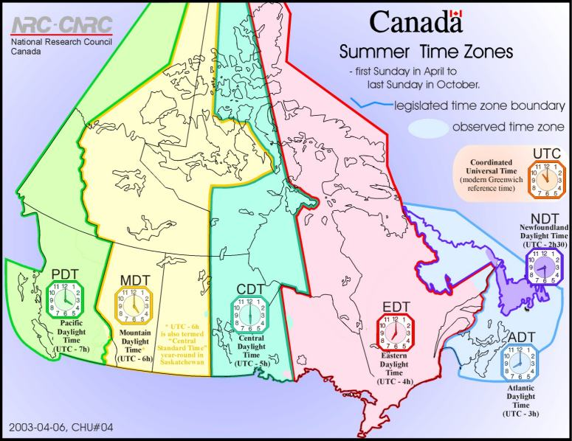

If the Time is…. | Then it is….
1:45 p.m. Mississauga, On | Victoria, BC
1:30 a.m. Halifax, NS | Yellowknife, NWT
4:00 p.m. in Edmonton, AB | Thunder Bay, ON
1:05 a.m. Montreal, QC | St. John’s, NFLD.
6:00 p.m. St. John’s, NFL | Toronto, ON
2:30 p.m. Fredericton, NB | Winnipeg
Your flight is 4 hours long. It is 3:00 p.m. in Whitehorse, YT, what time will you arrive in Fredericton, NB?
Your flight is 5.5 hours long. It is 1:00 p.m. in Victoria BC. What time will you arrive in Charlottetown PEI?
Your flight is 3.5 hours. It is 7:00 a.m. in Iqaluit NU. What time will you arrive in Victoria, BC?
Your flight is 2.5 hours long. It is 6:00 a.m. Toronto. What time will you arrive in Gander, Newfoundland?

